Credits: Wikipedia, urban75, about.com, drugfreeworld.org
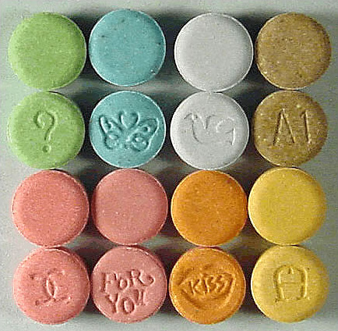
Ecstasy is a powerful stimulant and mood changer that speeds up your body system and alters your perception of the world.
It can make you feel both uplifted and relaxed, usually with an overwhelming urge to dance. HOWEVER, Ecstasy disturbs the body's ability to regulate its temperature which can lead to serious problems such as 'heat shock'. Experts suspect that here may be a link between brain damage and long term ecstasy use.
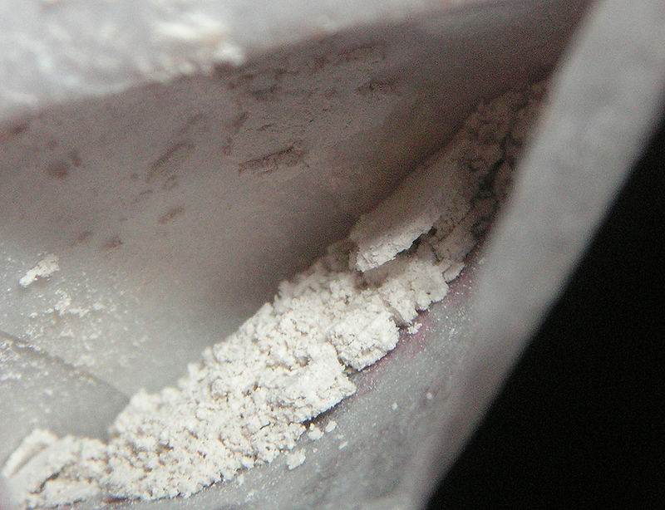
Heroin
Shortly after using, a feeling of euphoria overwhelm drug abusers, in which they have a warm flushing of the skin, a dry mouth and the feeling of having "heavy" arms and legs. Because heroin suppresses the central nervous system, the user experiences "cloudy" mental function. Users will begin to breathe at a slower rate and their breathing can reach a point of respiratory failure.
Long-Term Effects
- Heart complications
- Liver disease
- Kidney disease.
- Skin infections and abscesses
The most serious health effect of heroin use is the possibility of death due to accidental overdose.


Heavy Duty Glue Sniffing
Most inhalants act directly on the nervous system to produce mind-altering effects. Within seconds, the user experiences intoxication and other effects similar to those from alcohol. There are a variety of effects that may be experienced during or shortly after use, including:
- Inability to coordinate movement
- Hallucinations and delusions
- Severe headaches
- Rashes around the nose and mouth
Prolonged sniffing of these chemicals can induce irregular and rapid heartbeat and lead to heart failure and death within minutes.
Death from suffocation can also occur by replacing oxygen in the lungs with the chemical, and then in the central nervous system, so that breathing ceases.

